H.T No
Regulations:
A20

Sreenidhi Institute of Science and Technology
(An Autonomous Institution)
Code No: 8HC14 Date: 03-Feb-2024 (FN)

B.Tech II-Year I- Semester External Examination, Jan/Feb-2024 (Supplementary)
TRANSFORM TECHNIQUES AND NUMERICAL METHODS(EEE and ECE)

Time: 3 Hours Max.Marks:70

Note: a) No additional answer sheets will be provided.
b) All sub-parts of a question must be answered at one place only, otherwise it will not be valued.
c) Missing data can be assumed suitably.
Bloom's Cognitive Levels of Learning (BCLL)

Remember | L1 | Apply | L3 | Evaluate | L5
Understand | L2 | Analyze | L4 | Create | L6

Part - A Max.Marks:20

Answer all QUESTIONS.

 |  | BCLL | CO(s) | Marks
1 | Find the Laplace transform of  L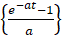 | L1 | CO1 | [2M]
2 | Define z-transform and find z{1}. | L1 | CO2 | [2M]
3 | Find the Fourier cosine transform of 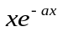 | L3 | CO3 | [2M]
4 | Write method of false position formula to find the root of f(x)=0 | L1 | CO4 | [2M]
5 | Write Gauss backward difference interpolation formula. | L1 | CO5 | [2M]
6 | Evaluate by Euler’s method,y¹ = x + y, y(0) = 1 and find y(0.1). | L5 | CO6 | [2M]
7 | Find the Laplace transforms of  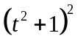 | L1 | CO1 | [2M]
8 | Define Parseval’s identity in Fourier transform | L1 | CO3 | [2M]
9 | Write predictor- corrector formula | L1 | CO6 | [2M]
10 | Define first shifting property in Laplace transform | L1 | CO1 | [2M]

Part – B Max.Marks:50
ANSWER ANY FIVE QUESTIONS. EACH QUESTION CARRIES 10 MARKS.

 |  |  | BCLL | CO(s) | Marks
11. | a) | Using the convolution theorem find  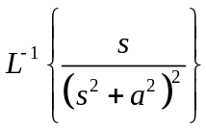 | L3 | CO1 | [5M]
 | b) | Using Laplace transform, solve  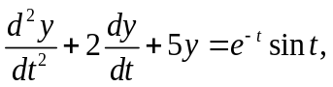  given that y(0)=0, y1(0)=1. | L5 | CO1 | [5M]
12. | a) | 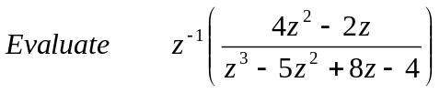 | L5 | CO2 | [5M]
 | b) | Solve the difference equation using z-transform  y_{n+2}-3y_{n+1}+2y_{n}=4^{n} with y(0)=0, y(1)=1. | L6 | CO2 | [5M]
13. | a) | Find the Fourier sine transform of  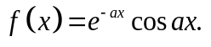 | L5 | CO3 | [5M]
 | b) | Find the Fourier transform of f(x) defined by 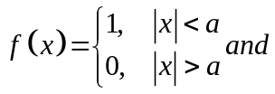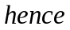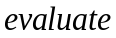  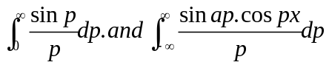 | L5 | CO3 | [5M]
14. | a) | Apply Newton – Raphson method to find an approximate root, correct to three decimal places, of the equation  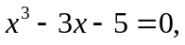 | L3 | CO4 | [5M]
 | b) | Evaluate using simpson’s 3/8th rule  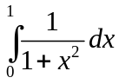 | L5 | CO4 | [5M]
15. | a) | Find y(25), given that y y(20)= 24, y(24) = 32, y(28) = 35 y(32) = 40 using Gauss forward difference Formula | L3 | CO5 | [5M]
 | b) | The population of a town in the decimal census was given below. Estimate the population for the 1895 | L5 | CO5 | [5M]
  Year x | 1891 | 1901 | 1911 | 1921 | 1931
  Population of y | 46 | 66 | 81 | 93 | 101
16. | a) | Using Runge-Kutta fourth order find y(0.1), y(0.2) given  y₁ = x²+y² and y(0) = 1. | L3 | CO6 | [5M]
 | b) | Evaluate y1= x2 – y, y(0) = 1 using Taylor’s series method and find y(0.2), y(0.4). | L5 | CO6 | [5M]
17. | a) | Find the Laplace transform of  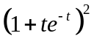 | L3 | CO1 | [4M]
 | b) | Find the z- transform of  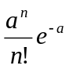 | L3 | CO2 | [3M]
 | c) | Show that the Fourier sine transform of 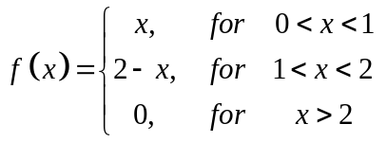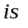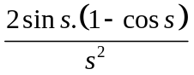 | L3 | CO3 | [3M]
18. | a) | Evaluate  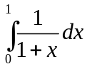  using Simpson’s 1/3rd rule taking h = 0.1. | L3 | CO4 | [4M]
 | b) | Using Newton’s forward interpolation formula, and the given table of values  Obtain the value of f(1.4). | L3 | CO5 | [3M]
  x | 1.1 | 1.3 | 1.5 | 1.7 | 1.9
  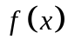 | 0.21 | 0.69 | 1.25 | 1.89 | 2.61
 | c) | Find an approximate value of y for x=0.1, if  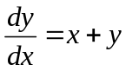  and y=1 at x=0 using Picard’s method. | L3 | CO6 | [3M]
-- 00 -- 00 –

